AI Secondary Brain – Complete HR + Technical Interview Answers (Tanglish + Easy English)
Gulshan, idhu dhaan final interview notes. Idha padichaa project pathi 0 knowledge → confident explanation level-ku poiduv. Ellame un project file-la irukkura information base pannirukken.
Pasted markdown.md
AI Secondary Brain
Interview Ready
Simple English
Tanglish Explanation
One-line introduction (30 seconds):
AI Secondary Brain is a privacy-focused AI application that records conversations, converts speech into text, summarizes important points, extracts action items, and answers questions from previous conversations. Everything works locally on the user's computer without sending data to the cloud.
Pasted markdown.md
⭐ Interview Flow (Remember this Order)
Audio Recording
User records a meeting or conversation.
Speech to Text
Faster-Whisper converts audio into text locally.
Save Transcript
Transcript, summary, embeddings, and reports are stored in SQLite.
AI Processing
Ollama creates summaries, action items, and semantic search embeddings.
Ask Questions
User can chat with previous conversations and get answers with source references.
Idha mind-la vechiko. Interview-la 70% questions idha suthithaan varum.
1️⃣ What is the Project?
HR Answer (Easy English)
Writing
AI Secondary Brain is a private AI-powered memory assistant. It records conversations, converts speech into text, summarizes the discussion, extracts important action items, and allows users to ask questions from previous conversations. All processing happens locally on the user's computer, so the data remains private.
Tanglish Meaning
Idhu oru personal memory assistant madhiri work pannum. Meeting, lecture, interview practice, discussion ellam record pannalam. Record pannina audio text-a convert pannum, summary kudukkum, important tasks extract pannum, later "Yesterday meeting-la enna decision?" nu kettalum answer pannum.
Pasted markdown.md
One-Line Version
AI Secondary Brain is a local AI application that remembers conversations and helps users search and chat with them later.
2️⃣ Why did you build this Project?
Interview Answer
Writing
Many people attend meetings, classes, and discussions but forget important information later. Existing AI note-taking apps usually upload data to cloud servers, which creates privacy concerns. So I built AI Secondary Brain as a local-first application that keeps user conversations private while providing summaries, search, and Q&A features.
Tanglish Explanation
Problem:
- Meeting mudinju notes marandhururom.
- Lecture-la important points miss panniduvom.
- Cloud apps privacy issue.
Solution:
- Local machine-la process.
- Data veliya pogadhu.
- AI help pannum.
Keyword: Local-first + Privacy.
Pasted markdown.md
3️⃣ What Problem does it Solve?
Problem | Solution in AI Secondary Brain
Forget meeting details | Automatic summary.
Hard to find old discussions | Semantic search + keyword search.
Manual notes take time | Speech converted into text automatically.
Need follow-up tasks | Action item extraction.
Privacy concern | Everything stored locally.
Pasted markdown.md
Easy English
The project helps users remember conversations, search past discussions quickly, and get AI-generated summaries without sending personal data to cloud services.
4️⃣ Technologies Used
Full Tech Stack
Layer | Technology
Frontend | React 18, Vite, Tailwind CSS, Framer Motion, Recharts, Axios.
Backend | Python, FastAPI, SQLAlchemy, Pydantic, Uvicorn.
Speech-to-Text | Faster-Whisper.
AI Model | Ollama (Llama 3.1 8B), Mistral fallback.
Embedding Model | nomic-embed-text.
Database | SQLite.
Reports | ReportLab, python-docx.
Pasted markdown.md
Tanglish Memory Trick
- Frontend → UI.
- FastAPI → API.
- Ollama → AI Brain.
- Whisper → Speech to Text.
- SQLite → Stores everything.
5️⃣ Your Exact Contribution
Interview Answer (Important)
Writing
I worked on integrating the frontend, backend, local AI processing, and database into one complete application. I implemented the audio recording flow, transcription pipeline, conversation storage, AI summary generation, action item extraction, semantic search, dashboard APIs, and report export functionality.
Tanglish
Naan pannadhu:
- Audio record feature connect panninen.
- Whisper transcription integrate panninen.
- SQLite-la save panninen.
- Ollama summary/Q&A connect panninen.
- Dashboard API create panninen.
- PDF report export panninen.
Interview Tip
"My role" nu kekka:
"I developed and integrated the core application modules."
Don't say:
"GitHub-la download panninen."
6️⃣ How does it Work? (MOST IMPORTANT)
Full Workflow
Step 1 — Audio Recording
User records conversation.
Step 2 — Faster-Whisper
Converts speech into transcript.
Step 3 — SQLite
Saves transcript and conversation.
Step 4 — Ollama AI
Creates summary, action items, topics, risks, deadlines.
Step 5 — Embeddings
Transcript converted into vectors for semantic search.
Step 6 — Ask Questions
User asks natural language questions.
Step 7 — Export
Download PDF, DOCX, TXT report.
Pasted markdown.md
Easy English
The application records audio, converts it into text using Faster-Whisper, stores it in SQLite, generates summaries using Ollama, creates embeddings for semantic search, and allows users to ask questions about previous conversations.
Interview Follow-Up
Q: What is Semantic Search?
Semantic search finds information based on meaning, not exact words.
Example:
- User: "deadline"
- Transcript says "submit tomorrow"
- AI still finds it.
7️⃣ Database Used
SQLite
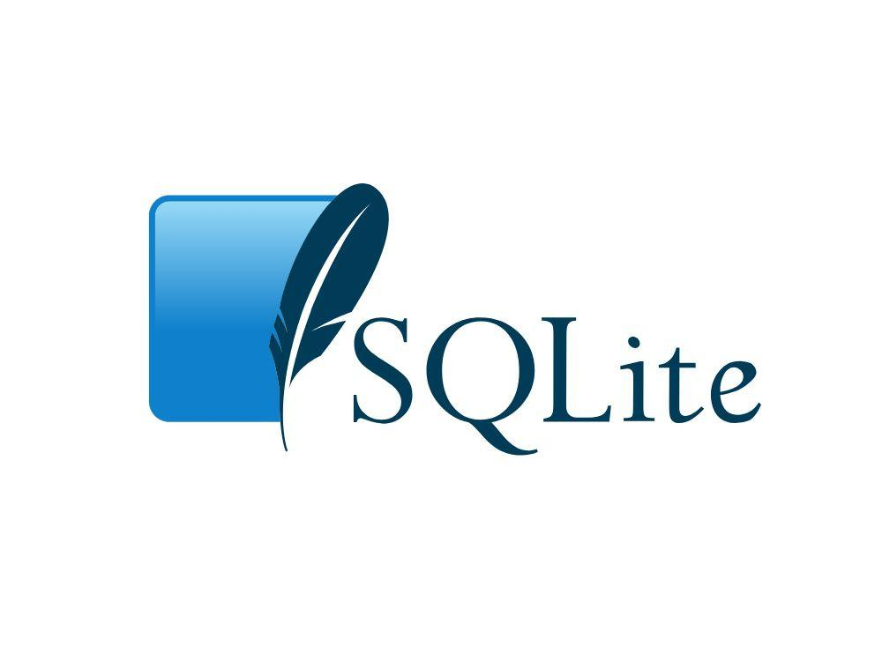
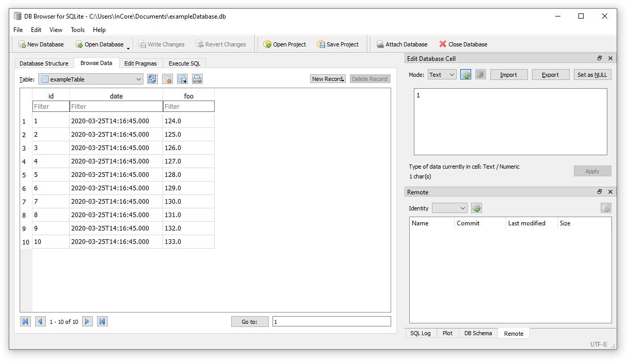
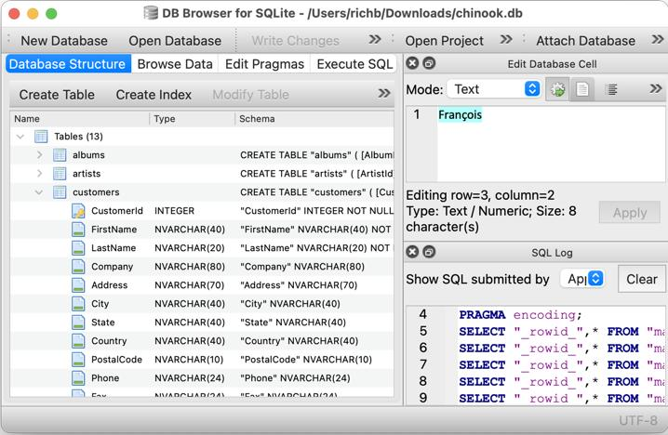
Interview Answer
AI Secondary Brain uses SQLite as the local database because it is lightweight, easy to manage, and does not require a separate database server.
Pasted markdown.md
What is Stored?
Table | Purpose
conversations | Conversation information.
audio_files | Audio metadata.
transcripts | Speech-to-text output.
transcript_chunks | Split text for semantic search.
embeddings | Vector representations.
summaries | AI-generated summaries.
action_items | Tasks extracted.
qa_history | Question-answer history.
reports | Exported reports.
Pasted markdown.md
Tanglish
SQLite = One file database (secondary_brain.db). Install panna MySQL venam.
8️⃣ APIs Used
Backend APIs (FastAPI)
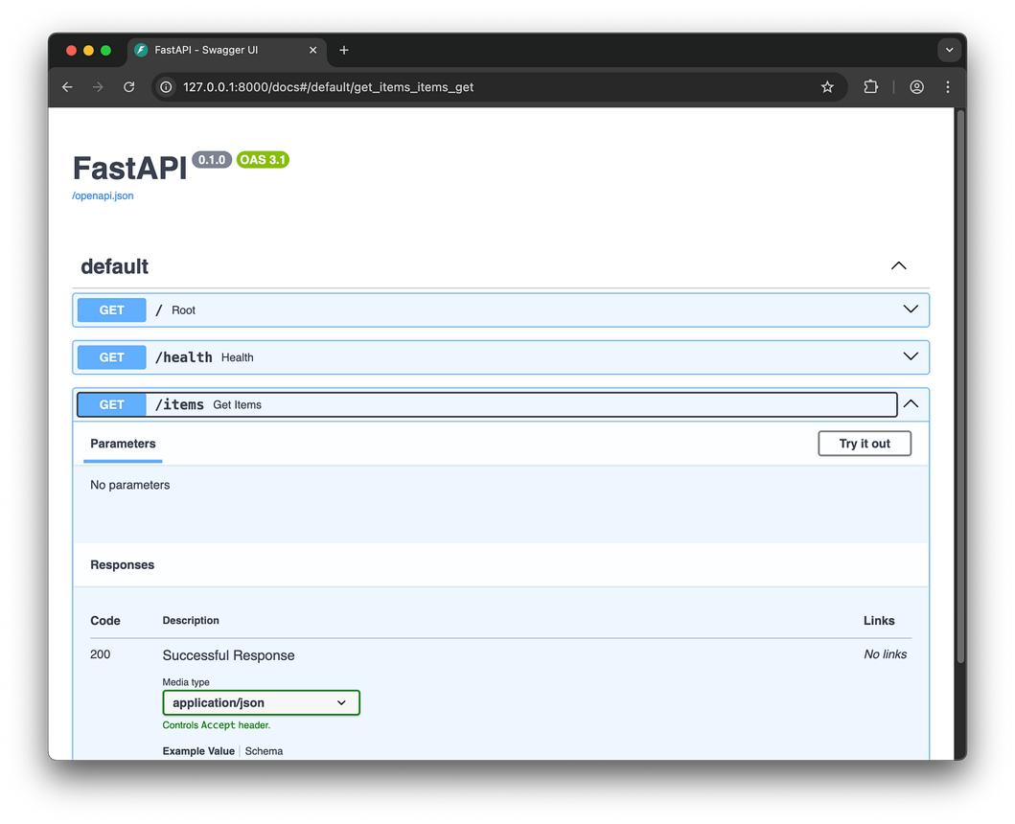
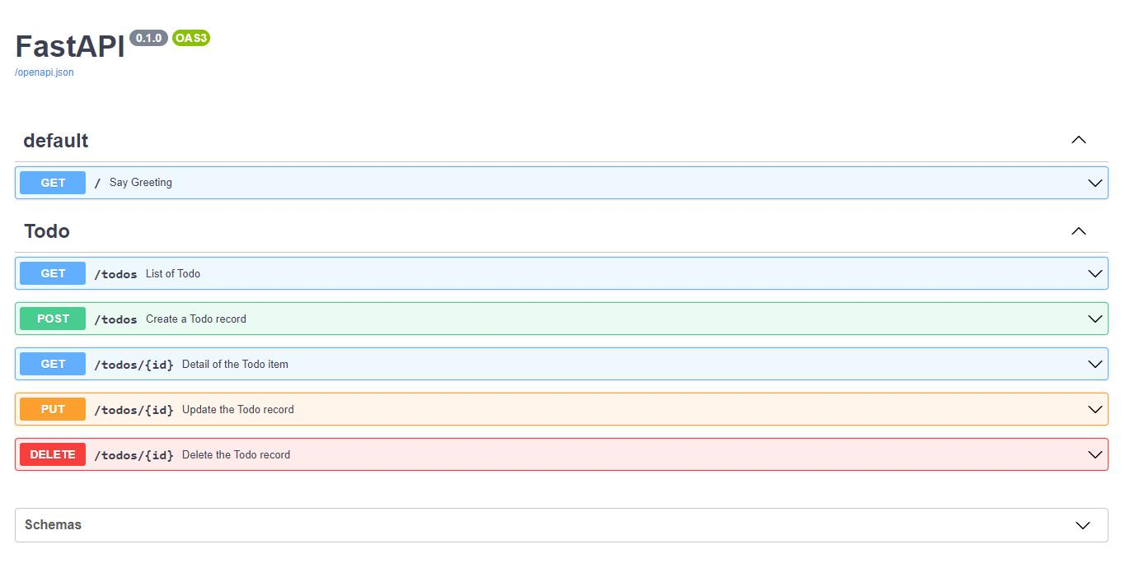
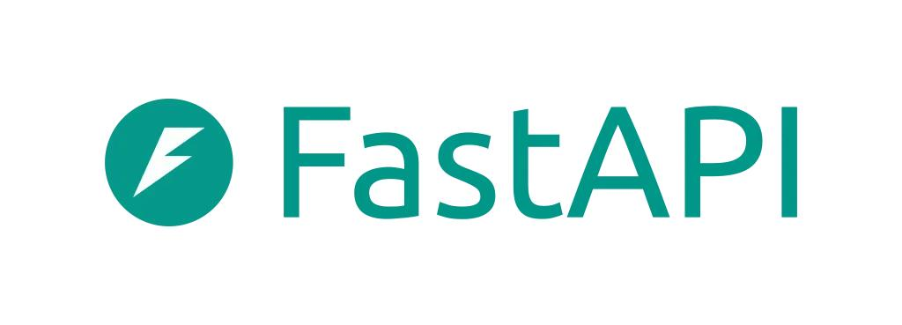
5
Interview Answer
I created REST APIs using FastAPI to upload recordings, retrieve conversations, search memory, ask AI questions, generate reports, and fetch dashboard statistics.
Pasted markdown.md
Important APIs
API | Purpose
POST /recordings/upload | Upload audio.
GET /conversations | View conversations.
POST /memory/search | Semantic search.
POST /questions/ask | AI Q&A.
POST /reports/generate | Create reports.
GET /action-items | Fetch tasks.
Tanglish
Frontend React → Axios → FastAPI → SQLite/Ollama → Response → React UI.
9️⃣ Challenges Faced
Interview Answer
Writing
The biggest challenges were converting speech accurately, generating meaningful summaries locally, improving semantic search quality, and keeping the application fully offline while maintaining good performance.
Pasted markdown.md
Top 5 Challenges
Challenge | Meaning
Speech accuracy | Different voices and accents.
Large conversations | Long transcripts.
Semantic search quality | Finding correct meaning.
Offline AI | No cloud API.
Performance | AI model speed.
🔟 How did you Solve Challenges?
Challenge | Solution
Speech accuracy | Used Faster-Whisper.
Offline AI | Used Ollama locally.
Semantic search | Embedding model + hybrid search.
Reports | ReportLab & python-docx.
Data privacy | SQLite local storage.
Pasted markdown.md
Easy English
I solved these problems by using Faster-Whisper for transcription, Ollama for local AI processing, embeddings for semantic search, and SQLite for secure local storage.
1️⃣1️⃣ What did you Learn?
Interview Answer
Writing
Through this project, I learned how to build a complete AI-powered full-stack application. I learned FastAPI backend development, React frontend integration, REST APIs, SQLite database design, speech-to-text processing, semantic search using embeddings, and local LLM integration with Ollama.
Pasted markdown.md
Learned Skills
- React
- FastAPI
- REST API
- SQLite
- AI integration
- Whisper
- Ollama
- Embeddings
- Semantic Search
- Report Generation
1️⃣2️⃣ What would you Improve?
Interview Answer (Best Freshers Answer)
Writing
If I continue this project, I would improve speaker identification, multilingual support, better search accuracy, calendar integration for reminders, and mobile application support. I would also optimize performance for longer conversations.
Good Improvements
Future Feature | Benefit
Speaker Identification | Identify who spoke.
Multilingual Support | Tamil + English.
Calendar Integration | Auto reminders.
Mobile App | Use anywhere.
Better Search | More accurate retrieval.
1️⃣3️⃣ Expected Follow-up Questions (Very Important)
Q1. What is Ollama?
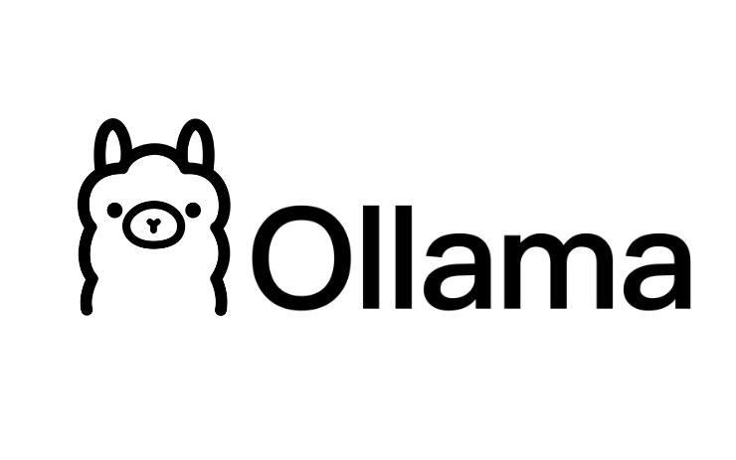
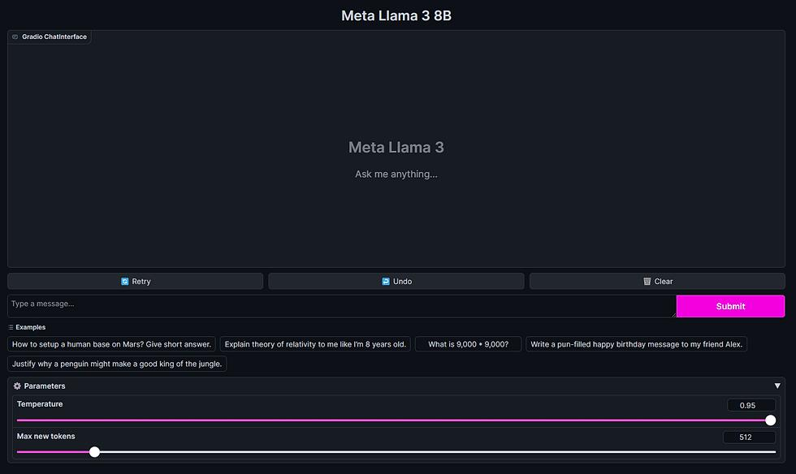
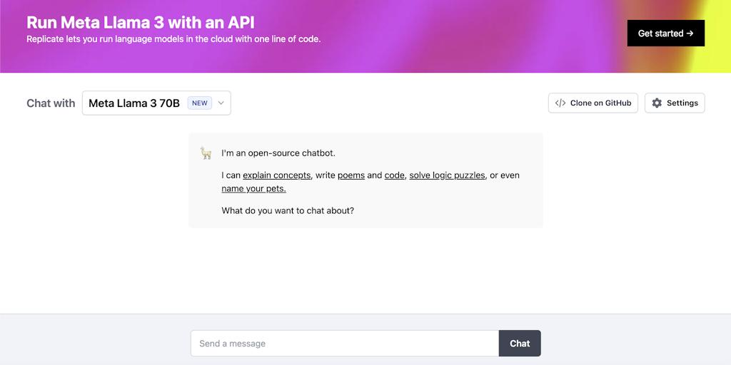
5
English
Ollama is a local platform that runs Large Language Models on a computer without using cloud APIs.
Tanglish
Cloud-ku data anuppama AI model namma laptop-la run pannum.
Pasted markdown.md
Q2. Why use Faster-Whisper?
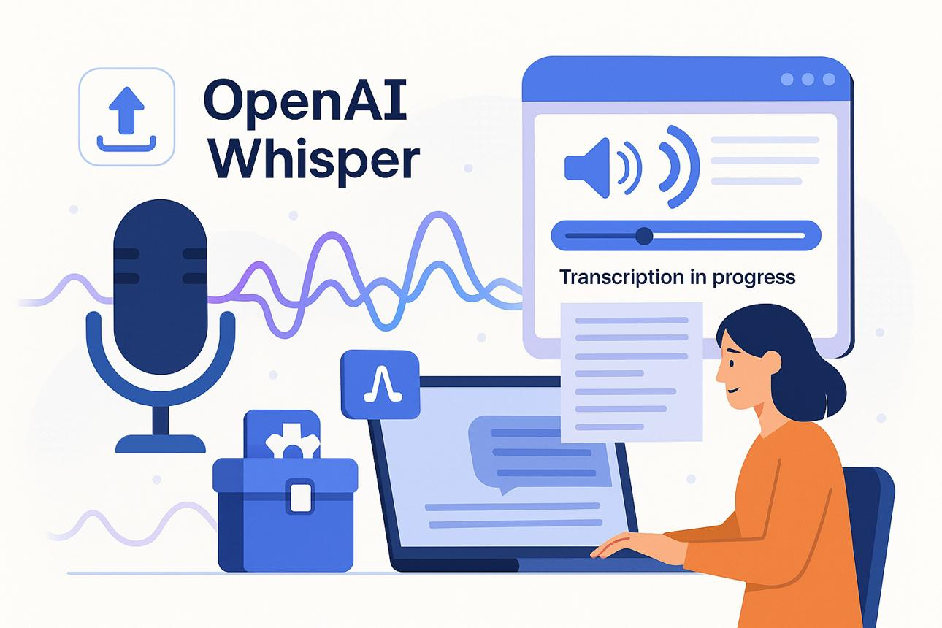
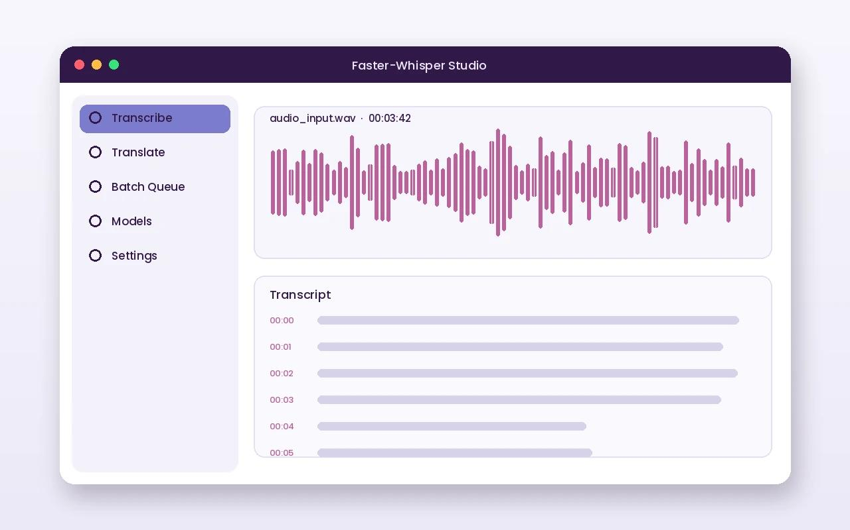
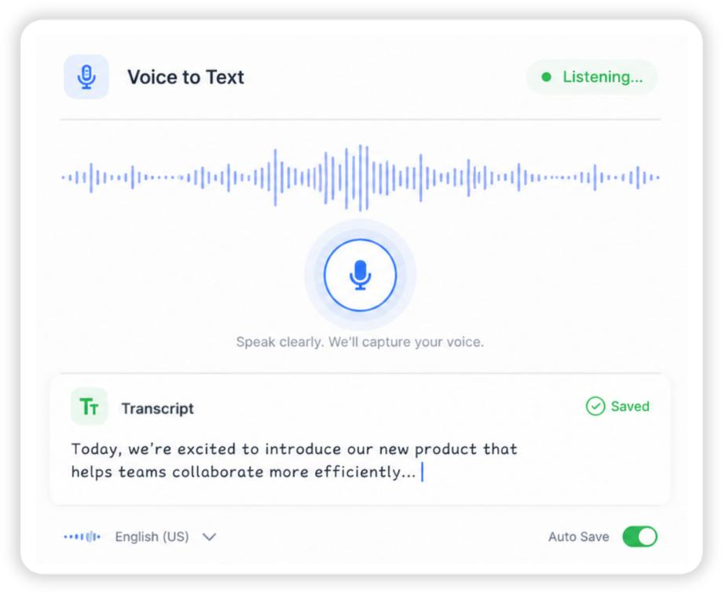
5
Faster-Whisper converts speech into text locally and works faster than the original Whisper implementation.
Pasted markdown.md
Q3. What is Embedding?
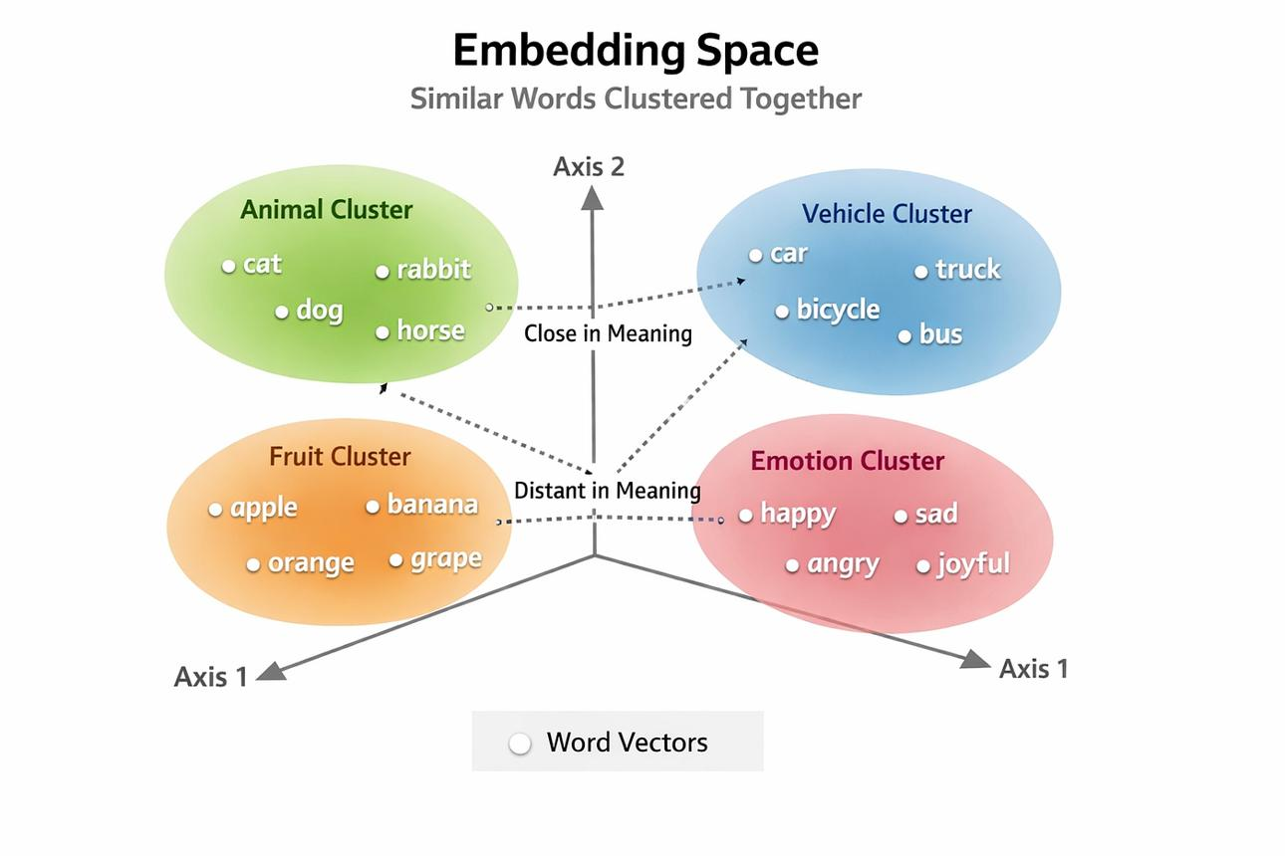
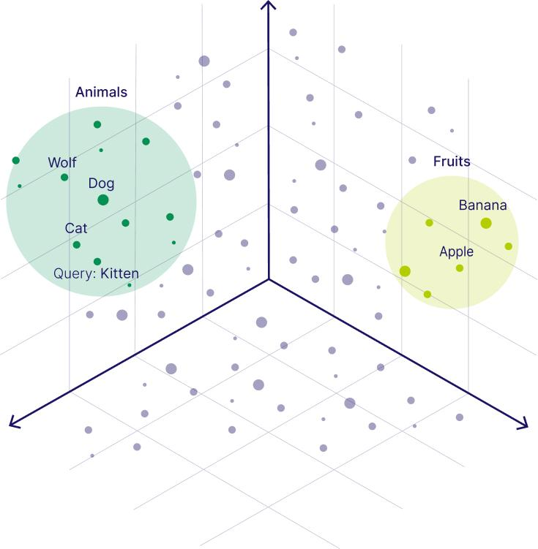
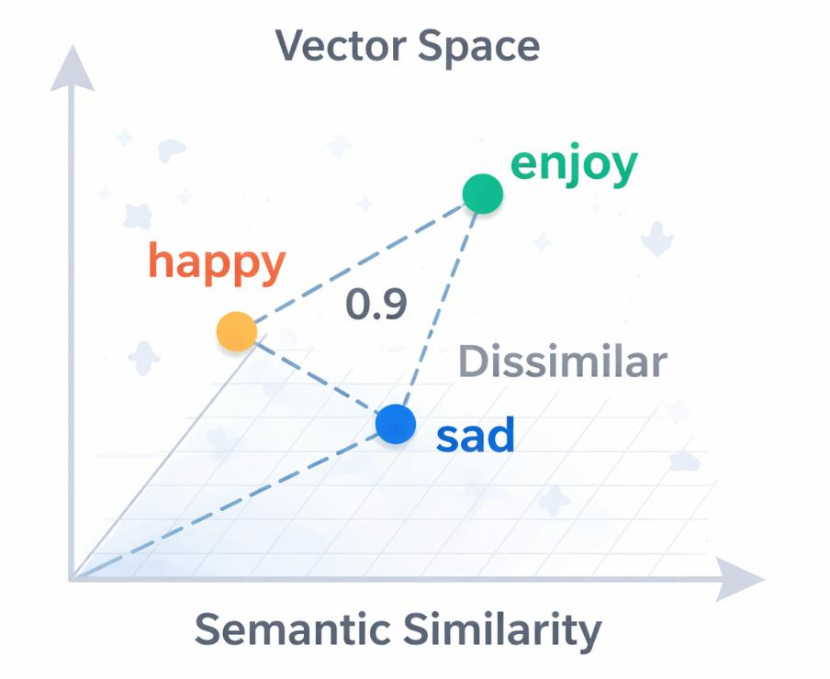
5
Easy Definition
Embedding converts text into numerical vectors so AI can understand meaning.
Example
Sentence:
- Submit assignment tomorrow.
- Tomorrow assignment submission.
Embedding understands both have same meaning.
Pasted markdown.md
Q4. What is Semantic Search?
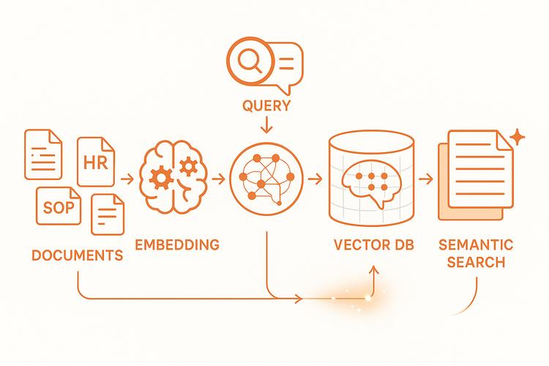
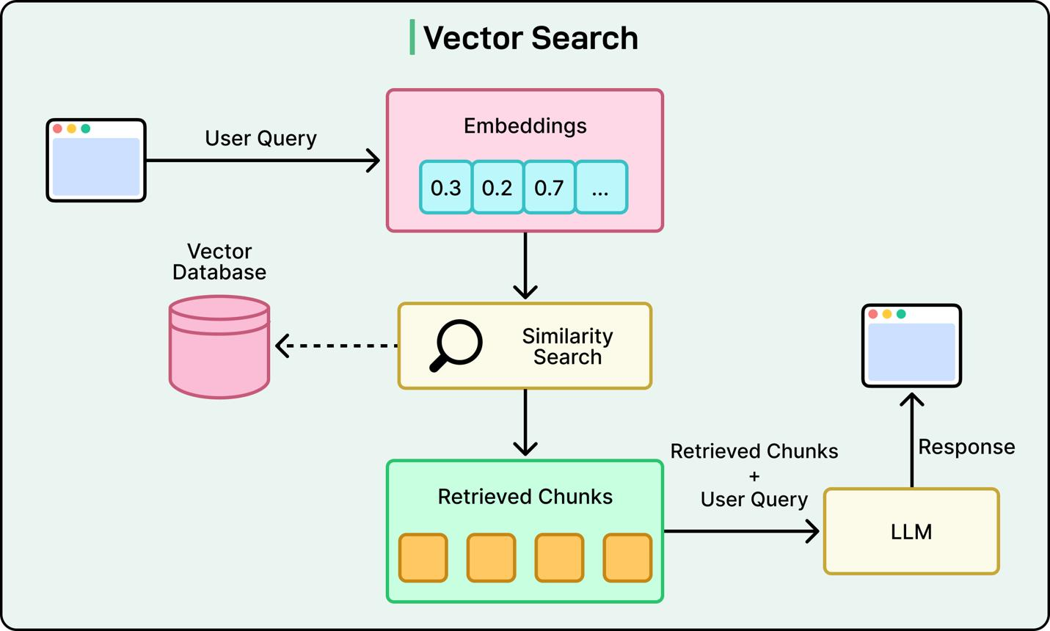
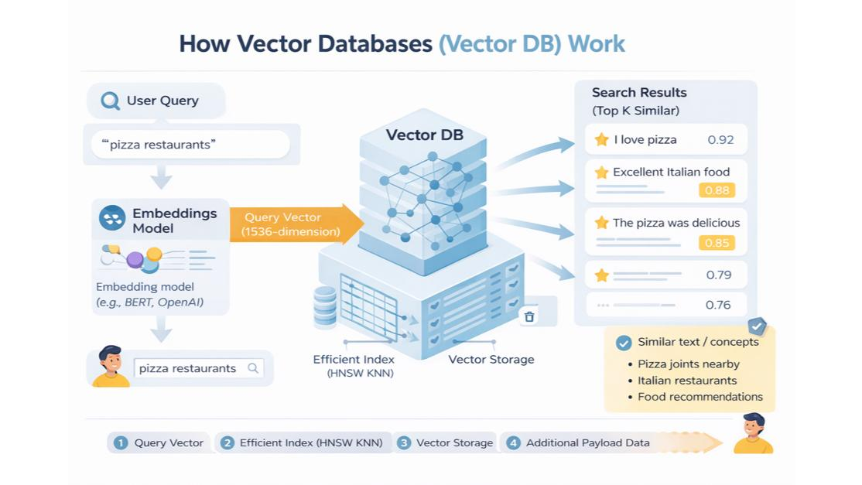
4
Semantic search searches based on meaning instead of exact keywords.
Example:
- Search "meeting deadline"
- Finds "submit report tomorrow."
Pasted markdown.md
Q5. Why SQLite instead of MongoDB?
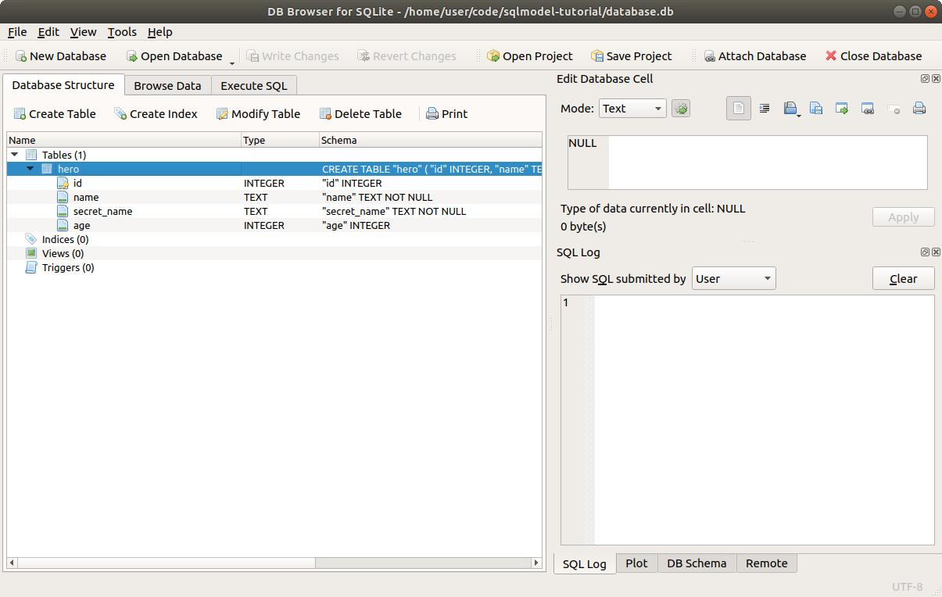
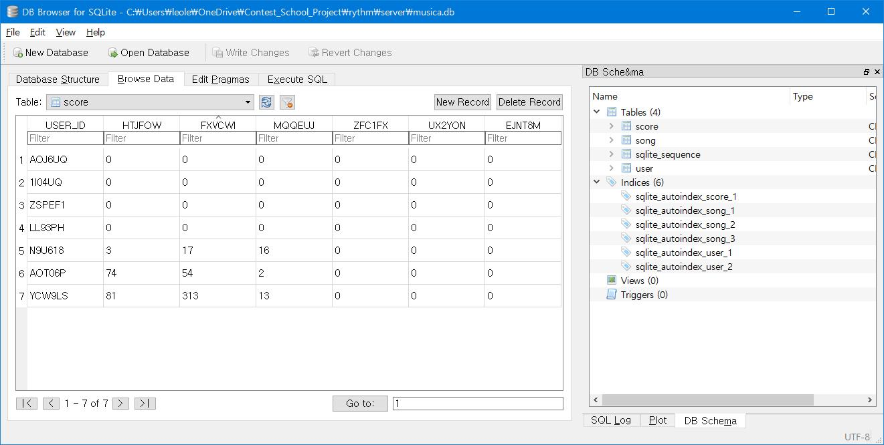
6
SQLite is lightweight, serverless, easy to install, and suitable for local-first applications.
Pasted markdown.md
Q6. Is your project online?
Answer
No. It is a local-first application. All AI processing, storage, transcription, and search happen locally.
Pasted markdown.md
Q7. How is Privacy Maintained?

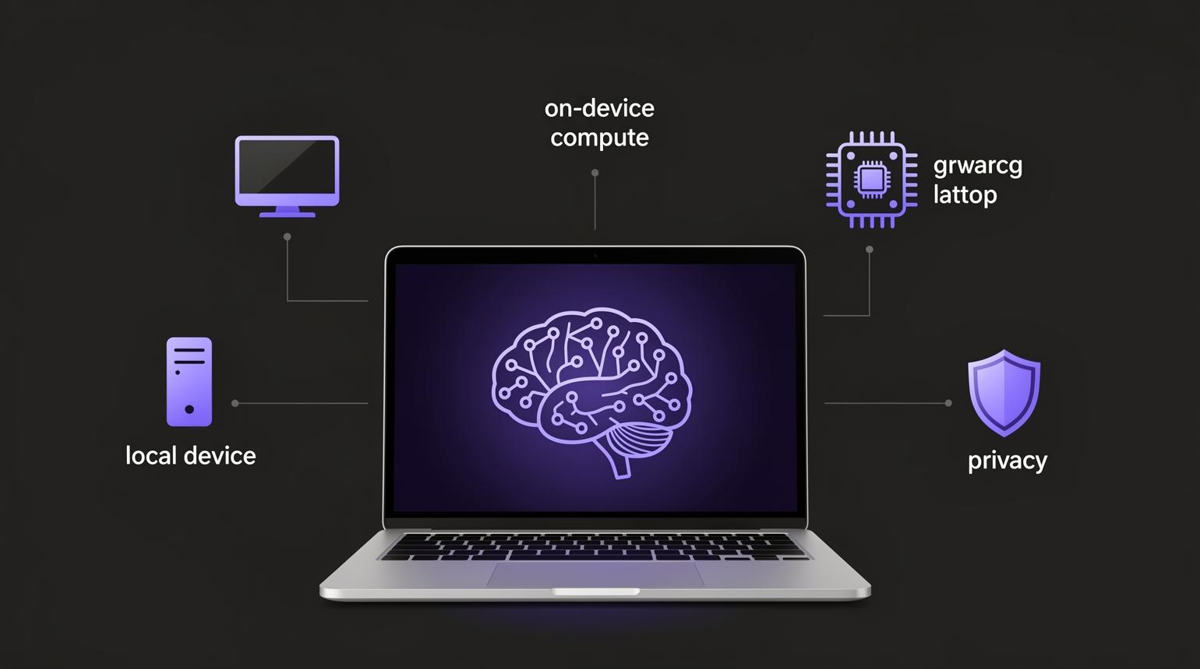
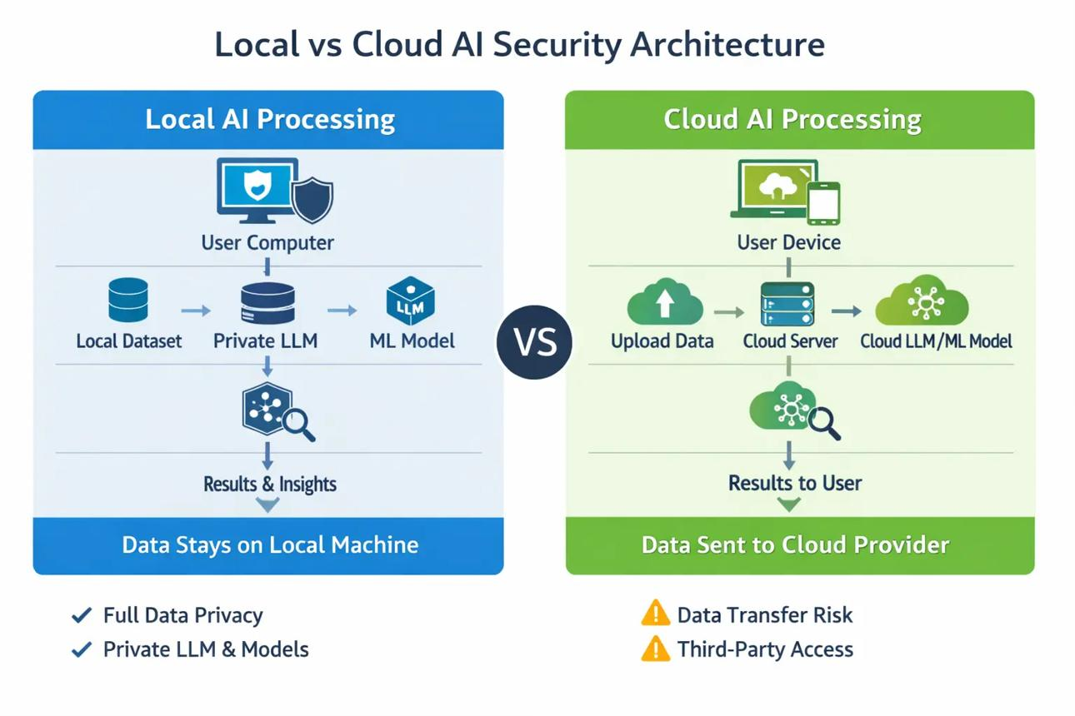
6
Recording starts only after user consent. No cloud storage or paid AI API is used.
Pasted markdown.md
Q8. What Reports are Generated?
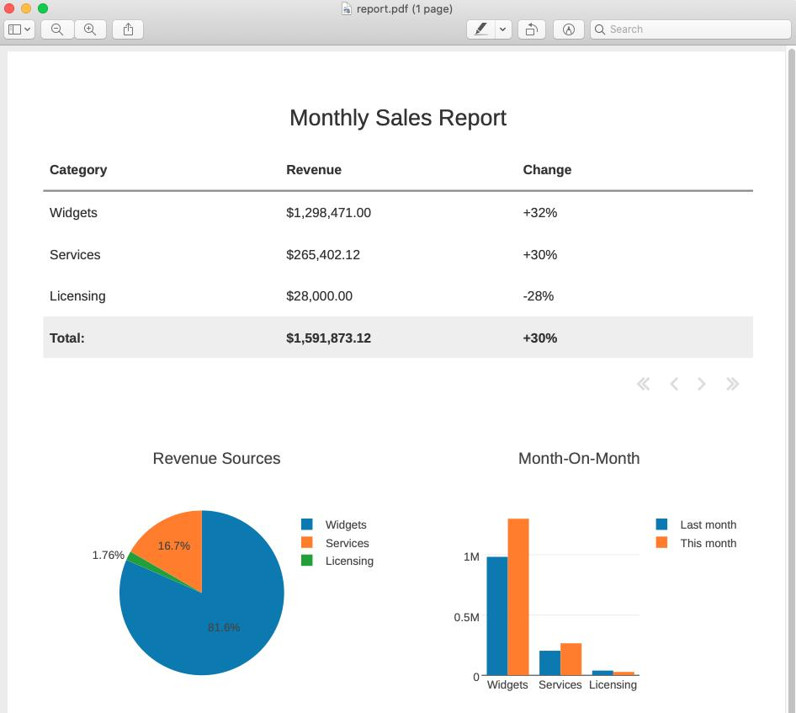
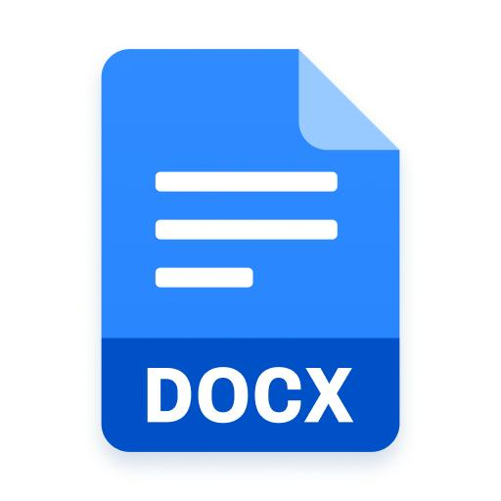

6
PDF, DOCX, and TXT reports containing summaries and action items.
Pasted markdown.md
Q9. How are Action Items Extracted?
Ollama analyzes the transcript and extracts tasks, deadlines, advice, risks, and opportunities.
Pasted markdown.md
Q10. Difference between Keyword Search and Semantic Search?
Keyword Search | Semantic Search
Matches exact word. | Matches meaning.
Fast. | Smarter AI search.
Pasted markdown.md
⭐ 2-Minute Interview Script (Memorize This)
Writing
My project is AI Secondary Brain, a privacy-focused AI memory assistant built using React, FastAPI, SQLite, Faster-Whisper, and Ollama.
The main goal of the project is to help users remember important conversations without sending their data to the cloud. The application records audio with user consent, converts speech into text using Faster-Whisper, stores transcripts locally in SQLite, and generates summaries, action items, and semantic search embeddings using Ollama.
Users can later ask questions about previous conversations, and the application retrieves relevant transcript sections using semantic search before generating answers. It also provides a dashboard and exports reports in PDF, DOCX, and TXT formats.
Through this project, I learned AI integration, REST API development, React frontend development, FastAPI backend development, SQLite database management, speech-to-text processing, and semantic search using embeddings.
This answer is around 90–120 seconds, which is perfect for most placement interviews.
🎯 Gulshan – Naalaiku Interview-ku Idha Mattum Padichaa Podhum
Top 15 keywords to remember
Local-first
Privacy
React
FastAPI
SQLite
Ollama
Faster-Whisper
Speech-to-Text
Summary
Action Items
Embeddings
Semantic Search
REST API
PDF Export
Dashboard
Interview tip:
If the interviewer asks any question, try to connect your answer back to these keywords. Most follow-up questions will come from these concepts.

